***Final Revision, May 2024***

**2024-2025**

**Parent and Family Engagement Policy for Shared Student Success**

**East**

**Elementary School**

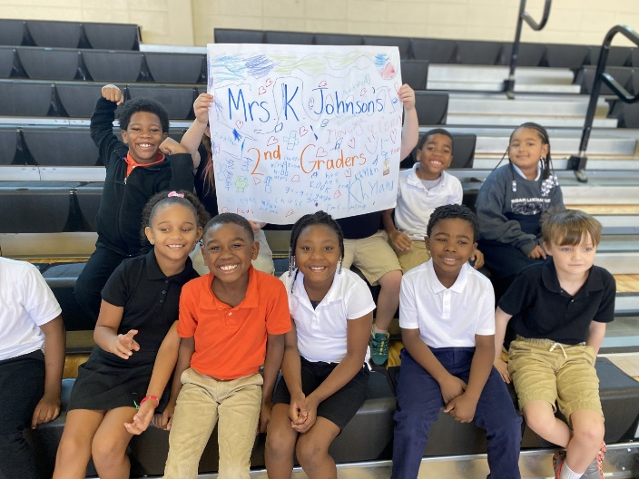

School Plan for Shared Student Achievement

#### What is it?

This is a plan that describes how East Elementary will provide opportunities to improve family engagement to support student learning. East Elementary values the contributions and involvement of families to establish an equal partnership for the common goal of improving student achievement. This plan describes the

different ways that East Elementary will support family engagement and how families can help plan and participate in activities and events to promote student learning at school and at home.

#### How is it revised?

East Elementary School invited all families to review and revise this parent and family engagement policy, the school improvement plan, our school-parent compact, and the family engagement budget. Additionally, family input and comments regarding this plan are welcome during the school year through an online form. The plan is posted on our school website for families to view and submit feedback throughout the year. All feedback received during the year will be used to revise the plan for the next school year. We also distribute an annual survey online and by mail to ask families for their suggestions on the plan and the use of funds for family engagement. Families can also give feedback during several meetings and activities during the school year.

#### Who is it for?

All students participating in the Title I, Part A program, and their families are encouraged and invited to fully participate in the opportunities described in this plan. East Elementary will provide full opportunity for the participation of parents and family members with limited English, with disabilities, and of migratory children.

#### Where is it available?

This plan is being provided to you with our updated student handbook. The plan will be posted on the school website and social media. Families can also retrieve a copy of the plan in the front office of the school.

#### What is Title I?

East Elementary is identified as a Title I school as part of the Every Student Succeeds Act (ESSA). Title I is designed to support state and local school reform efforts tied to the challenging state academic standards to improve teaching and learning for students. Title I programs must be based on effective means of improving student achievement and include strategies to support family engagement. All Title I schools must jointly develop with parents and family members a written parent and family engagement policy.

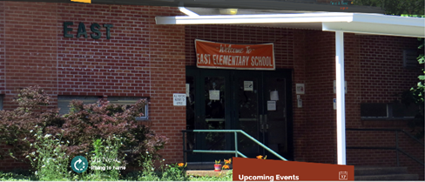

### 1B

**2B**

**When students, schools, families, and communities come together – we CAN achieve our goals!**

**1A**

#### 

#### East Elementary School

2480 Ashport Road

Jackson, TN 38305

<https://www.jmcss.org/east>

**District Beliefs**

**2024-2025**

**Belief Statements**

1 **B**uild strong, successful programs in three broad areas - academics,

athletics, and the arts.

2 **E**mpower schools, administrators, teachers, and staff with high-quality

instructional and curriculum material that are aligned to improving student

achievement.

3 **L**everage opportunities for diversity to support conditions that value all

individuals and programs.

4 **I**nvest in employees by providing financial and professional support.

5 **E**ducate all students in a safe, nurturing school environment that promote

healthy choices and opportunities for optimal learning.

6 **V**alue all employees, students, and families by distributing resources

equitably for the purpose of improving outcomes.

7 **E**ngage the broader community in an effort to support the whole child and

advance the progress of the school system.

**2024-2025**

**East Elementary School Goals**

**Increase proficiency on TN Ready—**

The school focus for **reading** is: to increase student achievement through

research-based curriculum that focuses on complex texts and literacy rich instruction by 7 %.

The school focus for **math** is: to build a strong foundation in K through 5 math through a research-based curriculum that carefully sequences the mathematical progressions into expertly crafted modules by 7%.

**Parent and Family Engagement**

East Elementary believes that family engagement means the participation of parents and family members in regular two-way, and meaningful communication involving student academic learning and other school activities, ensuring that:

* Families play an integral role in assisting their child’s learning;
* Families are encouraged to be actively involved in their child’s education at school; and
* Families are full partners in their child’s education and are included, as appropriate, in decision-making and on advisory committees to assist in the education of their child.

# School-Parent Compact

As part of this plan, East Elementary and our families will develop a school-parent compact. A compact is a written agreement that families, teachers, and students jointly develop to explain how everyone will work together to ensure all students reach grade-level standards. The compacts will be reviewed and updated annually based on feedback from families, students, and teachers during various events and the annual School Forum. The school-parent compacts are also displayed in each classroom, shared with families during parent-teacher conferences, posted on our school website https://www.jmcss.org/east and extra copies are always available in the front office. If you would like to provide feedback on the compact any time during the year, please contact your child’s teachers and we will reach out to you.

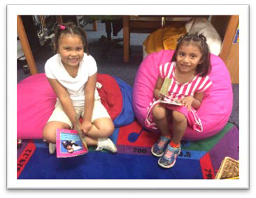

# East Elementary is branching out!

East Elementary will take the following measures to empower and support families as an important foundation of our school in order to strengthen the school and reach our goals.

### 7A

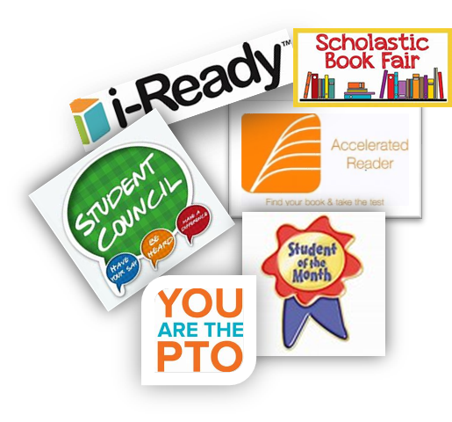 **We Will:**

* Provide ongoing support and strategies to faculty and staff in order to improve communication with families and ideas to increase family engagement in reading and math for our students outside of the classroom. Staff will also share best practices in family engagement during regularly scheduled faculty meetings and parent events.
* Ensure that all information related to school and family programs, meetings, and other activities is published in English and Spanish; posted on the school website; and included in the monthly school newsletter for all families.
* Partner with early childhood programs, middle and high schools, college- and career-ready resources or organizations, parent resource centers, or other

**7E** programs (as applicable) to help prepare parents and their children for successful school transitioning.

* + Communicate with all families and the community on a regular basis regarding school-wide events and activities, through phone messages, our website, social media, and flyers.
  + Work with our families to develop relevant trainings and helpful presentations to educate our staff on the importance of parent and family engagement and how to support student learning.
  + Provide necessary materials and handouts for parents at conferences, meetings, and activities to help parents work with their child to improve their child’s achievement.
  + Use our Partners in Education and School Community Team to improve awareness of the activities and events listed in the school parent and family engagement policy.
  + Collect feedback from parents and family members at all events, place input cards around the building, and post a suggestion form on the school website in order to respond to parents’ requests for additional support for parent and family engagement activities.

# Let’s Get Together!

East Elementary will host events to build the capacity for strong family engagement and support a partnership among the school, families, and the community to improve student academic achievement. See updates on our website, Facebook page, and on Twitter.

#### Annual Title I Meeting

We invite you to a time of learning and sharing about our Title I program, including our parent and family engagement policy, the school-wide plan, and the school-parent compact.

#### *Family Math and Reading Fun Nights

#### Parent-Teacher and Student Conferences

Scheduled updates on your child’s progress. In person or virtual conferences will be held in accordance with district mandates)

#### [https://keithpto.membershiptoolkit.com/assets/00318/PTO_join.jpg](https://keithpto.membershiptoolkit.com/packet/12796)Why Join PTO?

#### Successful students make successful schools— which make thriving communities. Everyone benefits when families and school work together to support students.

#### *Spring Field Day

#### Student Awards’ Programs

We look forward to celebrating your child’s success and growth both academically and socially

*Spe



Parent and Family Engagement Standards

East Elementary and our families have adopted the National PTO Standards for Family-School Partnerships as the school’s model in engaging parents, students, and the community. These standards are:

1. Welcoming All Families into the School Community
2. Communicating Effectively
3. Supporting Student Success
4. Speaking Up for Every Child
5. Sharing Power—Families and school staff are equal partners in decisions that affect children and families and together inform, influence, and create policies, practices, and programs.
6. Collaborating with Community

**I am interested in learning more about joining East Elementary’s Title 1 Committee!**

**Name:**

**Child’s Name and Grade Level: Address: Phone Number:**

**Email Address:**